Using KSpider to get assessment on a kubernetes cluster

|  |  |  |  |  |  |
| --- | --- | --- | --- | --- | --- |
| No. | Version | Date | Description | Modified By | Document Name |
| 1 | V0.1 | Sep 20 2023 | Draft version | Hugo Juárez h50032669 | TBD |
| 2 | V0.2 | Sep 27 2023 | Second Revision | Hugo Juárez  h50032669 | Using kspider to get assessment on a kubernetes cluster |

# Background:

In order to provide a good migration pipeline for Kubernetes clusters, discovery of the resources is needed. As it can help the user understand the current status of a cluster so a correct evaluation of the migration risks, selection of proper destination cluster version and scale can be performed.

# Summary of tools used:

Kspider is a tool used to collect information about the source cluster. And provides cluster-related data such as: Kubernetes version, scale, workload quantity, storage, and in-use images. This data can be useful to understand the status of the cluster and evaluate migration risks.

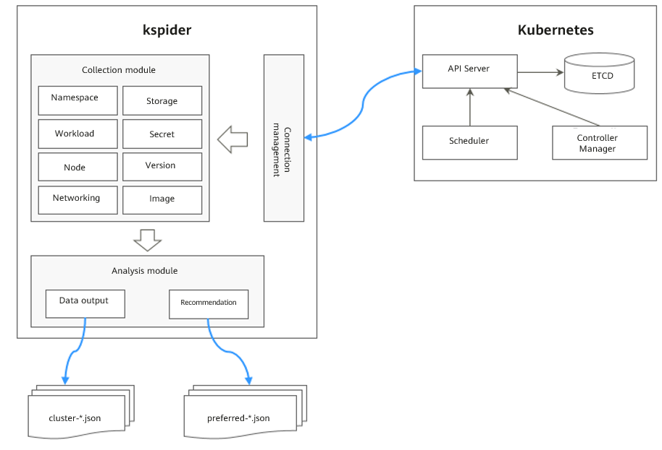

Kspider consists of three modules: collection, connection management and analysis. Collection module is tasked with collecting data from the source server including namespaces, workloads, nodes and networks. Connection module establishes connections with the API server of source cluster. Analysis module outputs the collected data(cluster-*.json) and provides recommendation regarding the destination cluster. (preferred-*.json).

# Example Guide

## **Considerations:**

Before using this tool, please ensure that you have prepared a server with kubectl installed to enable communication with the cluster from one of the nodes. The server must have at least 5 GB local disk space and at least 8 GB memory for the migration tool to work properly and store related data.

## **Usage of kspider:**

Step 1. Download the tool from: <https://ucs-migration-intl.obs.ap-southeast-3.myhuaweicloud.com/toolkits/kspider-23.3.0.0317182614.tar.gz>

Step 2. Extract the file with:

$ tar -xvf [**kspider-23.3.0.0317182614.tar.gz]**

Step 3. Run chmod to grant execute permission to each tools.

$ chmod u+x **tool_name**

Step 4. Run the tool.

Windows: run using kspider-windows-amd64.exe

Linux: run ./kspider-linux-amd64

### **Collect Data from the Source Cluster:**

Step 1. Connect to the source cluster using kubectl.

Step 2. Running the tool without any parameters to collect data from all namespaces in the cluster.

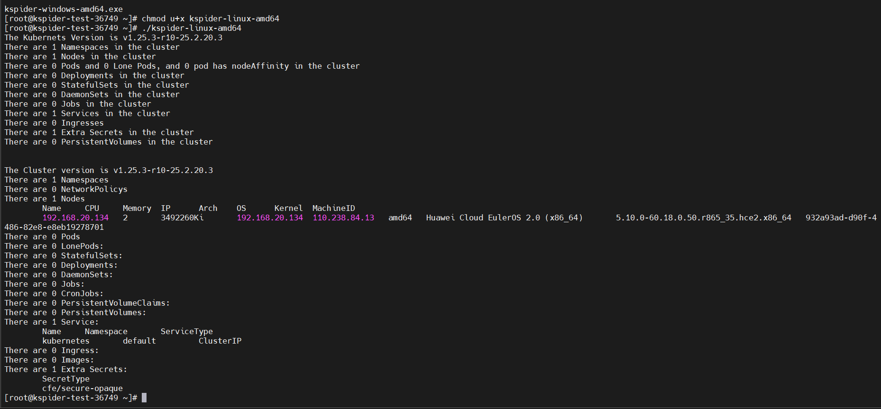

After the command is executed two files are generated in the same folder that the tools are located.

Cluster-*.json: contains data collected from the source and cluster applications. This data can be used to plan or analyze the migration.

Preferred-*.json: contains information about the recommended destination cluster.



Example of cluster-*.json file. Details on the description of each field in the file can be found on the following link. <https://support.huaweicloud.com/intl/en-us/usermanual-ucs/ucs_01_0174.html>

**The files generated are not formatted, with spaces or tabs.**

### **Evaluate the Destination Cluster**

The file preferred-*.json provides the recommended version and scale of the destination cluster. This can be helpful to better plan and prepare for the migration.



*Example of the preferred-*.json file.*

The description of the file can also be found on the following link: <https://support.huaweicloud.com/intl/en-us/usermanual-ucs/ucs_01_0174.html>

# FAQ:

* **Got a connection error when executing the tool.**

**-** *Please make sure that kubectl is installed and configured correctly to enable communication with the cluster.*

* **When trying to execute the tool got Permission denied.**

**-** *Remember to change permissions of the tool using* ***chmod u+x****.*

* **How to get information for certain namespaces only**

*- The tool can accept different flags, using “-n” flag where you can specify a certain namespace for information collection. Multiple namespaces can be specified by separating it with commas ( , ).*